**My Game Story #1 Info by: Alex Peterson**

My Story Board

Thursday, February 7, 2019

6:33 PM

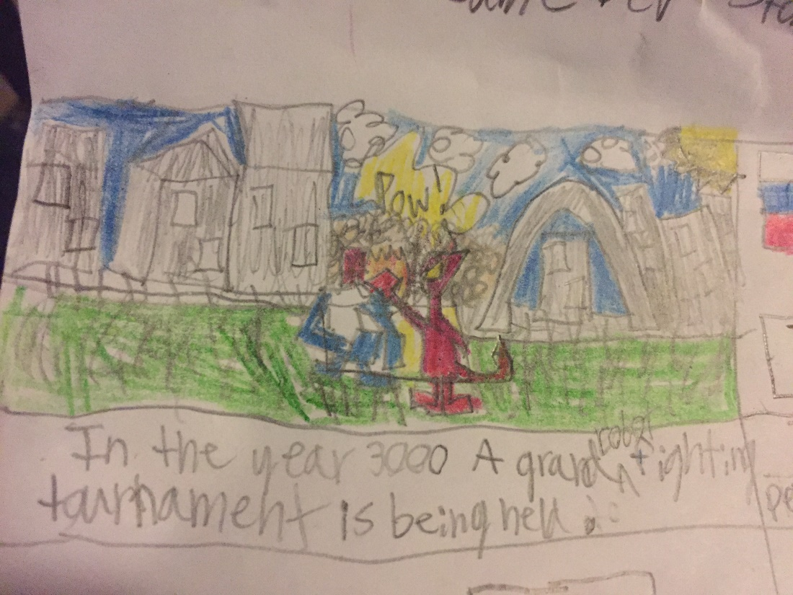

**In the year 3000 A grand robot fighting tournament is being held.**

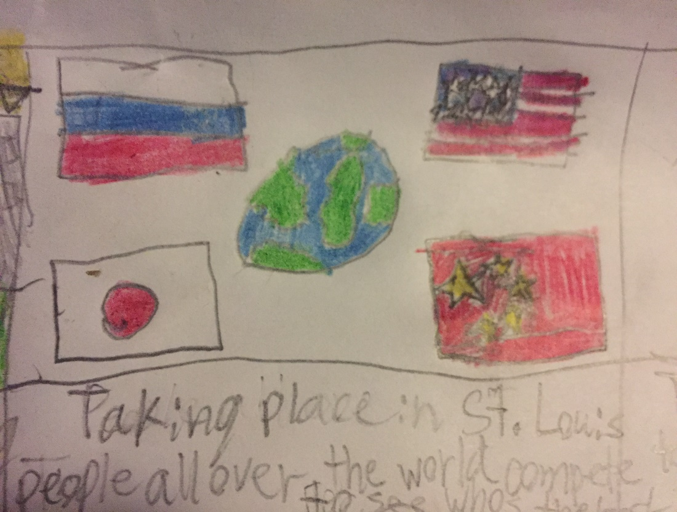

**Taking place in a post-apocolyptic St. Louis, people from all over the world compete to who has the best technology.**

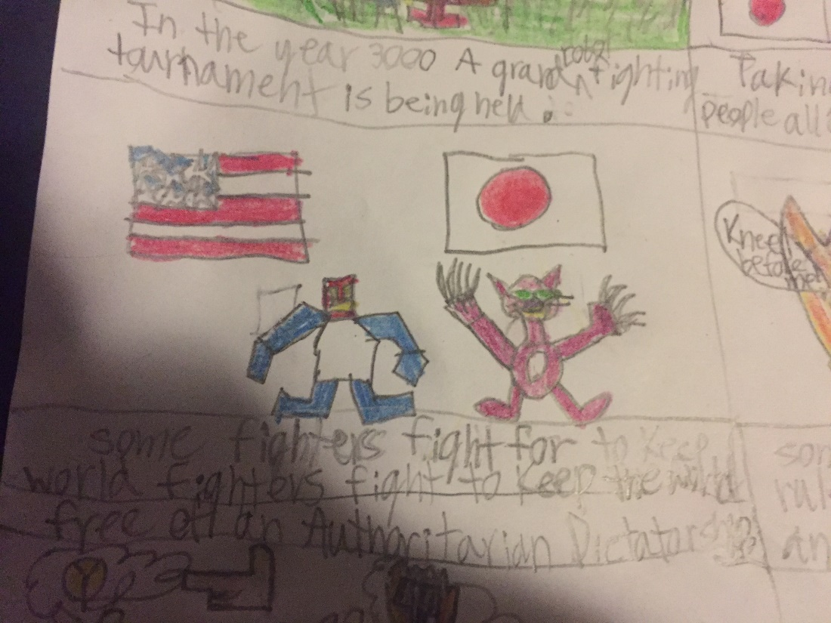

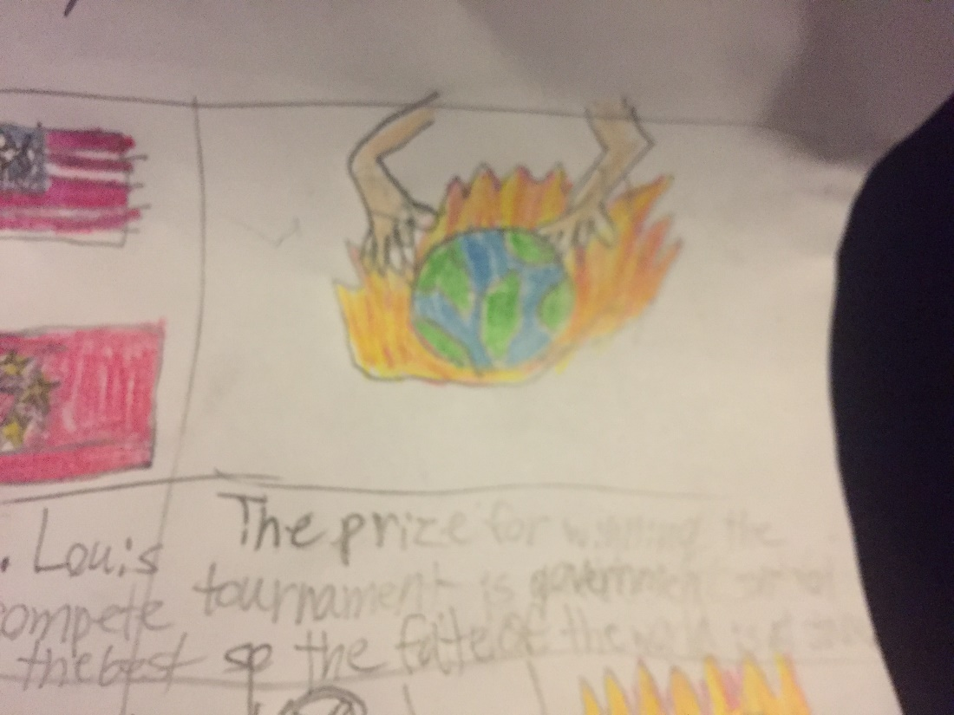

**The prize for winning this tournament is the winning team/country being represented becomes in control of the government in this post apocolypic future. So the future of the world is at Stake.**

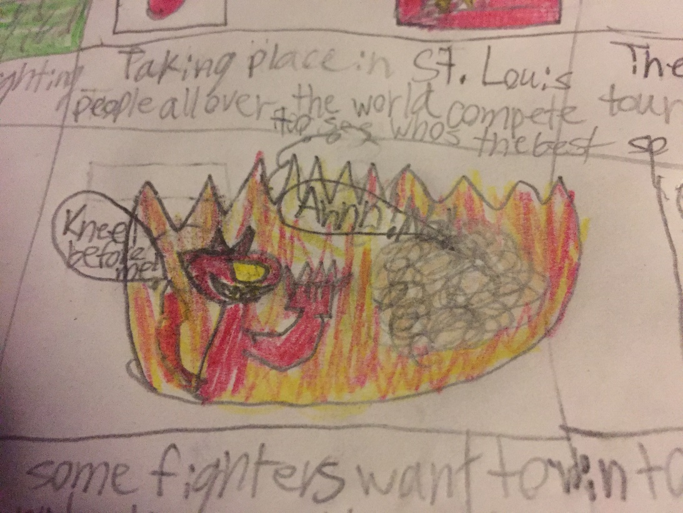

**Other fighters want to win to rule the world with an iron fist.**

**Some of these fighters want to rid the world of any possible authoritarian dictatorship and save the world.**

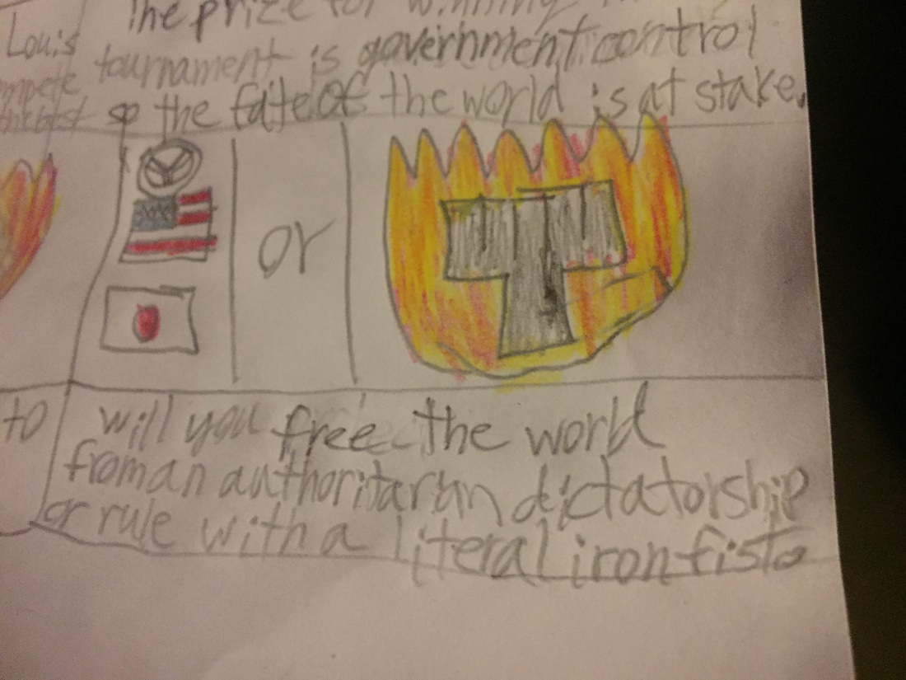

**Will you free the world from an authoritarian or rule the world with a literal iron fist?**

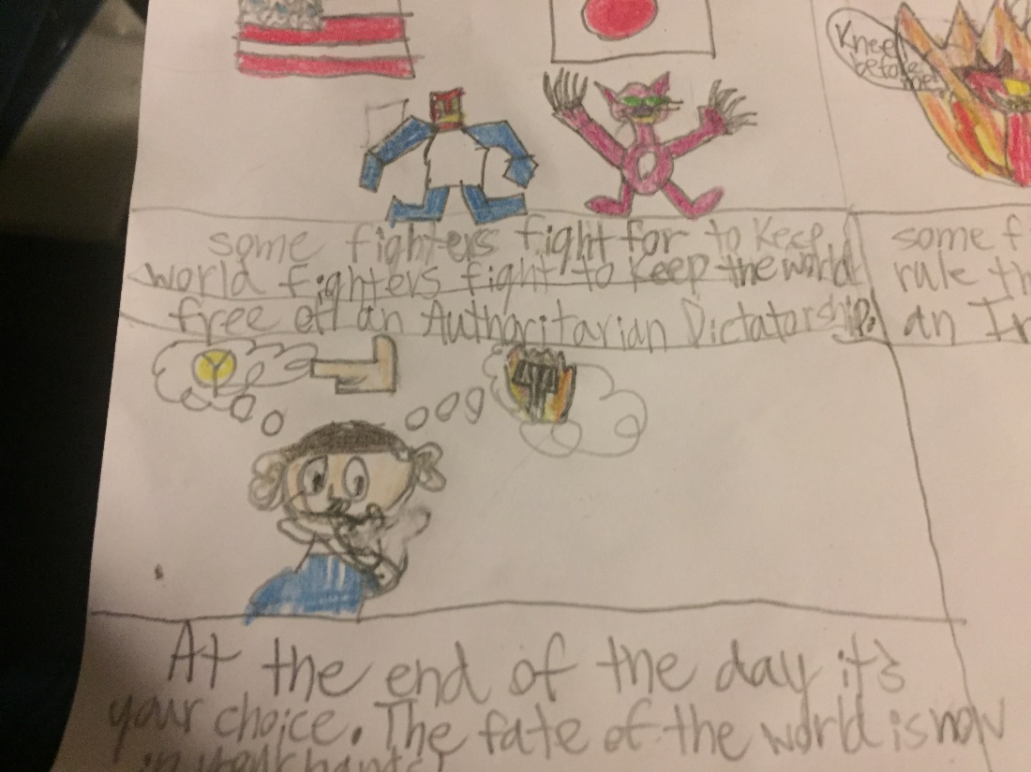

**At the end of the day it's your choice. The fate of the world relies is now in your hands.**

**Are you ready for the ultimate robot tournament?**

Machine generated alternative text:
Unity 2018.3.0f2 Personal - MainGame.unity - Robot Fighter Prototype - PC, Mac & Linux Standalone <DXII > 
File Edit 
C Game 
Assets 
GameObject 
Component 
Window 
Help 
"Center *Local 
ecollab • 
Account 
Layers 
n play 
Mute Audio 
Layout 
Stats 
811 PM 
2/12/2019 

Summary

Wednesday, February 6, 2019

11:54 AM

**Location of Game World:** A Post-apocolyptic Futuristic Hi Tech Earth Robot Fighting Tournament In St.Louis Missouri

**Time Frame:** The year 3000 A.D.

**Story summary:** In the year 3000 A.D in a post-apocolyptic Hi Tech St. Louis Missouri the first ever robot fighting tournament is being held for nations around the world to compete to see which country has the best robot fighter in the world. The winner of this competition has the fate of all nations at stake the winner of the tournament will have full control of the government of the world so will you and your robot win to free the world of an Authoritarian Dictatorship and keep the world free or will you and your robot win to take over the world with a literal iron fist? The fate of the world is in your hands!

**Characters and Background Characters:** Human beings from all over the globe as the background characters and Hi tech robots as playable characters.

**Playable Characters(Including Characters not in Prototype):** Libertron-1776 (Team U.S.A Robot)

Sputnik-3000 (Team Russia Robot)

La cucaracha Metallica-2000 (Team Mexico Robot)

Neko-Bot-5000(Team Japan Robot)

The Chrome Dragon(Team China Robot)

Valhalatron-2000 (Team Sweden Robot)

SteelKnight-4000(Team U.K Robot)

Pyramid-Bot-2500 (Team Egypt Robot)

Non Playable Characters(Not In Prototype):

Robert Washington (Team U.S.A Human Robot Trainer)

Pretrovic Drago (Team Russia Human Robot Trainer)

Juan Edwardo Cortez (Team Mexico Robot Trainer)

Ami Kobayashi (Team Japan Robot Trainer)

Hao Long (Team China Robot Trainer)

Derek Peterson (Team Sweden Robot Trainer)

Sir Edward Princeton (Team England Robot Trainer)

Benipe Akhom (Team Egypt Robot Trainer)

Target Audience: Casual for all ages

Main Selling Points

Wednesday, February 6, 2019

11:43 AM

* Simple and fluid and addictive gameplay
* High Replayability
* Simple and Colorful visuals

Competitive or Inspirational Game Titles

Wednesday, February 6, 2019

11:56 AM

**List of Possible titles for this game:**

Rock Em, Sock Em Robo Fighter!

Robo-Brawler 3000

Super Robot Tournament Fighter 3000

Super Robo Tournament Fighter 3000

Super Robo Tournament Fighter 3000: The Battle for Earth

Super Robo KO

Super Robo KO: The Battle for Earth